Login to Active.com

In order to login to most ACTIVE Network products, you must already have an ACTIVE Passport - please visit the applicable link below to register/create an account, login, or retrieve your password.
Register/Create Passport  https://passport.active.com/reg | Login with Existing Passport  https://passport.active.com | Retrieve Password  https://passport.active.com/forgot
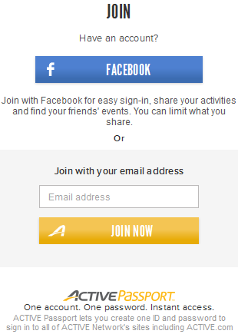 | 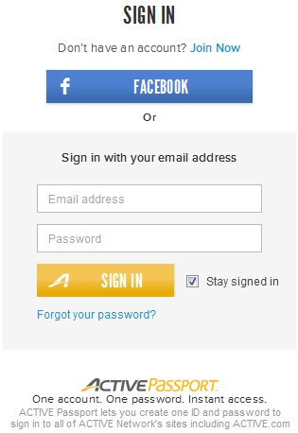 | 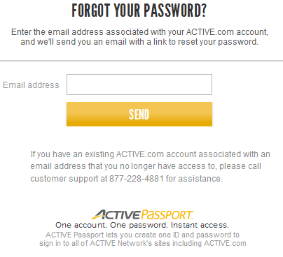
Below are instructions to login to ACTIVE.com with your existing account:
1. Navigate to (and bookmark) http://www.active.com
2. Click Sign In in the upper right-hand corner
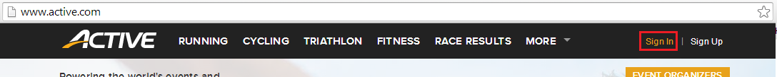
3. Enter your ACTIVE Passport username (email address) and password – Note this must be the same email address that you registered under.
4. Click Sign In
You will be redirected back to ACTIVE.com. Hover over your name in the upper right-hand corner to access the following items:
- View Profile
- My Events
- Order History
- Upgrade Account (ACTIVE Advantage)
- Settings

Purchase Additional Merchandise After Registration

After registration, you can add or edit additional purchase items such as merchandise or other optional items.

- Login My Events at http://myevents.active.com
- Find your registration event, click Purchase merchandise
​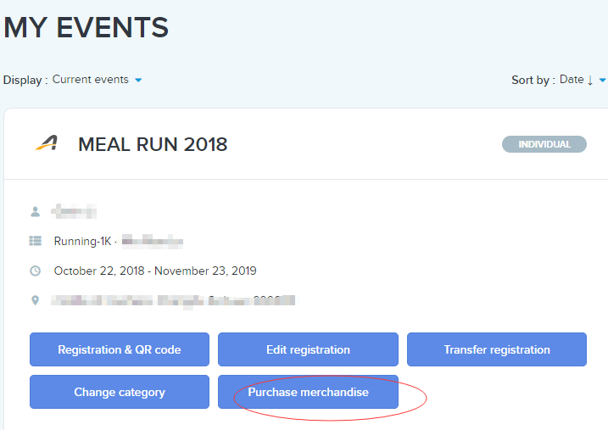
- Select desired items
- Enter quantities (if applicable)
- Click Continue
- Enter billing information
- Click Complete

